Job no-2

Job name:-html link(Anchor tag, Marque tag)

JOB 2,Input:

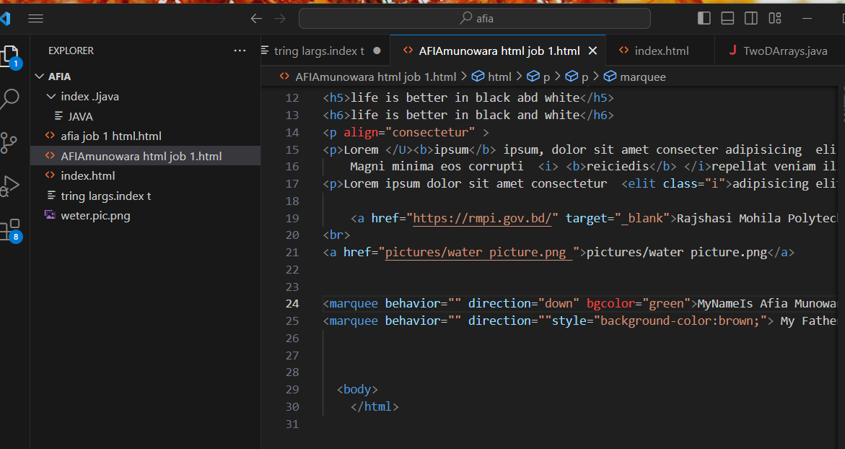

Job 2 output:

